T.C.
İSTANBUL YENİ YÜZYIL UNIVERSITY SOCIAL SCIENCES INSTITUTE



THESIS / DISSERTATION / PROJECT WRITING AND FORMATTING MANUAL

2025

PURPOSE
The purpose of this manual is to ensure that graduate theses/projects prepared in accordance with the Graduate Education and Training Regulations of the Institute of Social Sciences at İstanbul Yeni Yüzyıl University are written and printed according to specific standard rules.

SCOPE
Graduate students and thesis advisors in the departments affiliated with the Institute of Social Sciences at İstanbul Yeni Yüzyıl University are required to comply with the rules stated in this manual when preparing master's theses, doctoral dissertations, or projects for defence. The writing rules of the American Psychological Association (APA 7th edition, 2020) have been utilized in the preparation of this guide.

PAPER SPECIFICATIONS
All pages of the thesis/project must be printed single-sided on high-quality white paper. A4- size (210x297 mm), minimum 80-gram white paper must be used for the writing and printing of the theses.

PAGE LAYOUT
Margins:
  - Top margin: 3 cm.
  - Bottom margin: 3 cm.
  - Lef margin: 4 cm.
  - Right margin: 2,5 cm
Alignment: The text must be justified (aligned to both left and right margins) Paragraphs: The first line of each paragraph should be indented 1,25 cm from the left. Line Spacing: The text must be written with 1,5-line scaping.

Spacing:
  - Before: 6 pt
  - After: 6 pt

Page order and numbering: Page numbers must be placed at the bottom right corner of each page. All preliminary pages—excluding the inner and outer cover pages—such as approval, ethical declaration, preface, abstract (in both Turkish and English), table of contents, list of tables, list of figures, and list of abbreviations, must be numbered using lowercase Roman numerals (i, ii, iii, etc.). From the introduction section onward, Arabic numerals (1, 2, 3, etc.) must be used starting with page number 1.
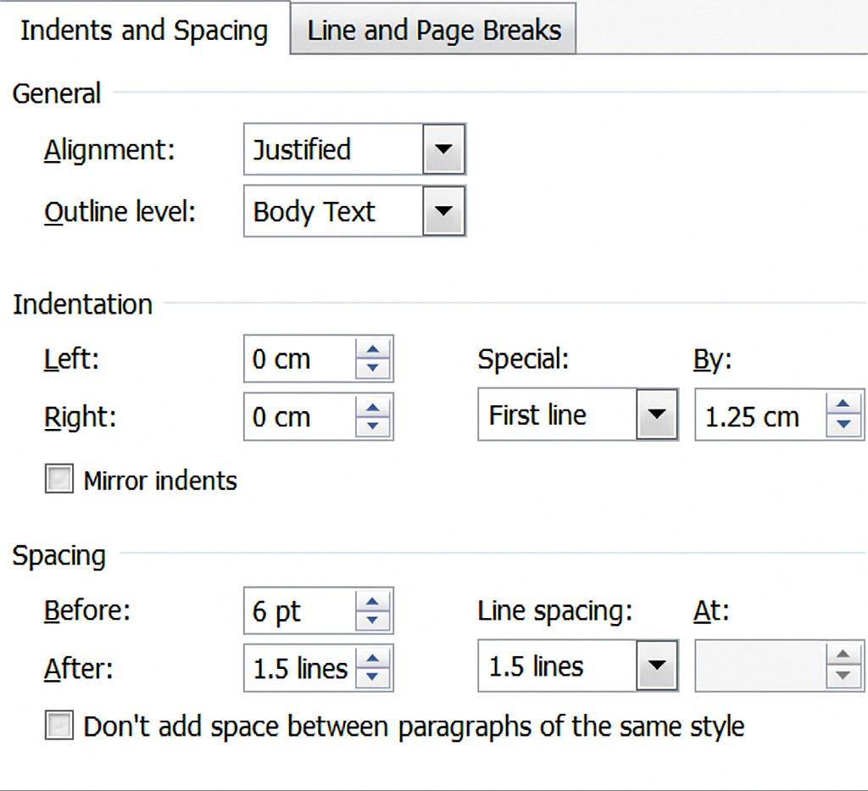

TYPOGRAPHICAL STANDARDS
Font: The thesis must be written in Times New Roman, 12-point font in Microsoft Word. Footnotes should be in 10-point font and single-spaced. The same font and font size must be used consistently throughout the entire thesis.
Line Spacing: The main text, including the bibliography, must be written with 1.5 line spacing. Text within tables and figures should be single-spaced. However, before continuing to the main text following a table or figure, 1.5 line spacing should be left as a blank space. A single space should follow all punctuation marks, and punctuation must be used in accordance

with the current guidelines of the Turkish Language Association (TDK) Spelling Guide. Words that require special emphasis may be written in italics.

MAIN AND SUBHEADINGS
Main chapter titles must be centre-aligned and written entirely in uppercase letters. Subheadings must be justified (aligned on both sides). Only the first letter of each word should be capitalized, and the entire heading should be written in bold.
Numbering of Headings: All sections and headings in the thesis must follow a systematic hierarchical structure. To clearly reflect this structure, each section and heading should be numbered accordingly. In this system, all headings are assigned numbers, and subheadings receive sequential numerical extensions of their parent heading. A period is placed after each number. Multiple digits in a heading indicate its position within the overall structure.

Example:

  - Chapter Titles: 1, 2, 3, 4...
  - Subtitles and their sublevels: 1.1., 1.1.1., 1.2., 1.2.1., 1.2.2., 2.1., 2.1.1., 2.1.2., etc.

THESIS STRUCTURE
The thesis must be organized according to the following sequence:
  - Outer Cover (Hard Cover): The advisor’s name must not appear on the outer cover. The date at the bottom of the cover page should be formatted as follows: “ISTANBUL, NOVEMBER 2017”
  - Inner Cover (Title Page): Institutional details and the type of study must be written in 14- point font, bold, and uppercase letters. The title of the thesis/project must be in 16-point font, bold, and uppercase letters. The name and title of the author, advisor, and jury members must be in 14-point font, bold, and uppercase letters. Place and date must also be in 14-point font, bold, and uppercase letters.

Thesis Approval Page
  - Ethical Statement
  - Preface: This section should briefly state the purpose, significance, and scope of the thesis, and may also include acknowledgments for individuals and/or institutions who provided material or moral support during the preparation of the project. It must not exceed one page.

  - Turkish Abstract (Özet) and Keywords: This section should present the aim, findings, and results of the research in a concise and objective manner, without interpretation. It must not exceed 250 words. At the end of the abstract, up to five keywords that best represent the study should be listed.
  - English Abstract and Keywords: The English abstract should be a direct translation of the Turkish abstract. The content of both versions must be identical. Keywords should also be listed in English under the heading Keywords.
  - Table of Contents: The title "Table of Contents" must be centre-aligned and not assigned a page number. Main chapter titles should be numbered sequentially as 1, 2, 3, etc.
  - List of Tables (if applicable)
  - List of Figures (if applicable)
  - List of Graphs (if applicable)
  - List of Abbreviations (if applicable)

  - Introduction: This section should include the research problem and its significance, its relation to prior research, research objectives, hypotheses (for quantitative studies), approaches (for qualitative studies), and rationale (for mixed methods studies). It should also explain the relationships among the study’s objectives, hypotheses, and design; the theoretical and practical contributions of the research; relevant literature review; and other key aspects such as variables, concepts, and the research population.

Main Chapters
  - Methodology
  - Findings: This section reports the findings obtained as a result of data analysis. Tables, figures, charts, and diagrams should be used in all types of research to present the findings in an organized manner. In qualitative research, this section may also include direct quotations or field notes.

  - Discussion and Conclusion: This section should present interpretations, evaluations, and inferences based on the research findings; justifications regarding whether the hypotheses were supported or not; comparisons with findings from other studies in the literature; comments on the generalizability of the results; strengths and limitations of the study; encountered ethical issues; contributions of the findings; and the implications of the study for theory, practice, and future research.

  - Bibliography: The reference list should begin on a new page immediately after the Discussion and Conclusion section. The heading BIBLIOGRAPHY must be centred, written in all capital letters, and not numbered.
  - Appendix: The heading APPENDIX must be centred, written in all capital letters, and not numbered. This section should include official and administrative documents related to the thesis (e.g., Ethics Committee Approval, Correspondence with Official Institutions), as well as any other required declarations. Each appendix should begin on a new page, labelled with capital letters (e.g., Appendix A, Appendix B) in bold and centred. The title of the appendix should follow on the next line, also in bold and centred.

RULES FOR CITATION AND FOOTNOTES
Throughout the thesis, you are required to document all works consulted by indicating the author(s) and year of publication. Such in-text citations provide readers with brief reference details and allow them to locate the full bibliographic entry in the alphabetically organized Bibliography section at the end of the thesis.
In-Text Citation: Whether quoting directly or paraphrasing an author’s ideas, proper citation is mandatory. Including the page number is not required for in-text citations; however, it may be added when deemed necessary by the author.
Direct Quotations: For direct quotations, cite the author’s last-name, year of publication, and the page number(s) in parentheses (e.g., p. 25 or pp. 34–36). For non-consecutive page references, separate the page numbers with commas (e.g., pp. 67, 72).
Direct quotations must match the original text exactly. Passages taken word-for-word from another author’s work, a previous publication by the same author, excerpts copied from a test, or instructions given to participants must be presented verbatim.
For short quotations (fewer than 40 words), integrate the quote into the text using double quotation marks and 1,5 line spacing.

Example:

“Çatışmalar ortaya çıktıkları zaman çeşitli yollarla çözülmeye çalışılır. Çatışmaların çözülebilmesinde iki tarafın da büyük bir rolü vardır. Çünkü çatışmalar ancak iki taraf da olaya sağlıklı bakabildiğinde etkili olarak çözümlenebilir” (Korkut, 2004, p.163).

For long quotations (40 words or more), format the quotation as a separate block without quotation marks. Begin on a new line and indent the entire paragraph 0.5 cm from both the left and right margins, using 2 line spacing.

Example:

Çatışmalar ortaya çıktıkları zaman çeşitli yollarla çözülmeye çalışılır. Çatışmaların çözülebilmesinde iki tarafın da büyük bir rolü vardır. Çünkü çatışmalar ancak iki taraf da olaya sağlıklı bakabildiğinde etkili olarak çözümlenebilir. Yaşamımızda çatışmaların sağlıklı olarak, başka bir deyişle iki tarafın da ikna olduğu, taviz de vermediği biçimde çözümlenebilme olasılığı oldukça düşüktür (Korkut, 2004, p.163).
If a work has two authors, always include both authors’ last names each time you cite the source.
If a work has three or more authors, provide only the first author’s last name followed by “et al.”, then the year of publication.
When citing group authors (such as organizations, associations, government agencies, or working groups) without established abbreviations, their full names must be written out in every in-text citation.
If the group author has a well-known or standard abbreviation, the full name should be provided the first time the source is cited, followed by the abbreviation in brackets. For all subsequent citations, only the abbreviation should be used.

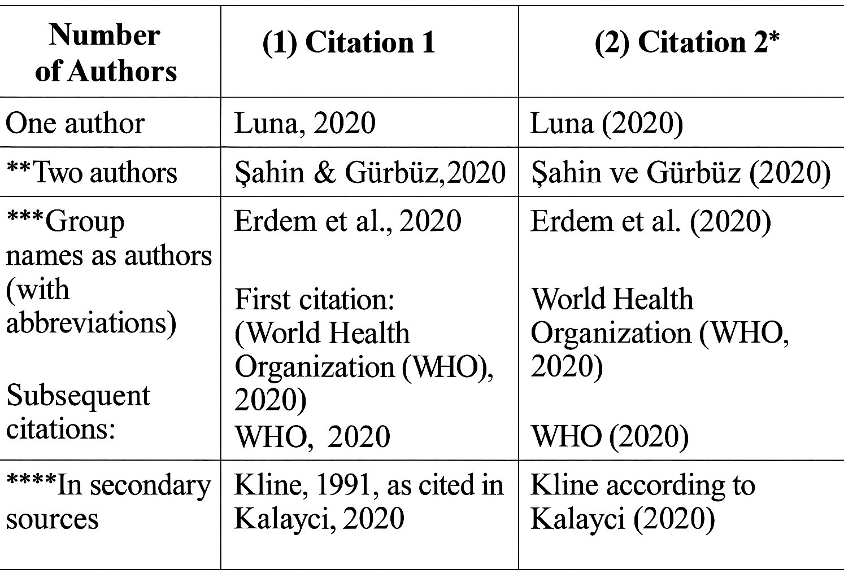
In some cases—though rarely—both the author’s name and the year of publication may be integrated into the narrative of the sentence. In such instances, do not include citation details in parentheses.

Example:
Walker compared reaction times in 2000.
Once a source has been cited within a paragraph, there is no need to repeat the publication year in subsequent references to the same source within that paragraph—as long as there is no risk of confusion with another work.

Example:
In a recent study on reaction times, Walker (2000) introduced this method. Walker also addressed a different topic.

Use of Single or Double Quotation Marks:
If a phrase in the original text is already enclosed in double quotation marks, it should be placed within single quotation marks in your citation.

Modifications and Explanations Within Quotations:
To indicate omissions within a sentence, use three spaced ellipsis points (...). If text is
omitted between two sentences, use four dots (. ). In this case, the first dot represents the period at
the end of the first sentence; the remaining three dots indicate the omission.

Works with No Author (Including Legal Documents) or Marked as “Anonymous”:
If a work has no listed author, cite it in the text by referring to the title of the work and the year of publication.

Examples:
- (Study Finds, 1982)
- College Bound Seniors (1979)
When citing legal documents, use the same format as for works with no author: include the first few words of the reference list entry (usually the title of the law, regulation, or court case), followed by the year.
If a source is marked as "Anonymous", use that word as the author's name in your citation:
- (Anonymous, 1998)
In the reference list, the entry should also begin with “Anonymous” and be alphabetized accordingly.

Authors with the Same Surname:
If multiple works are cited where the first authors share the same surname, include their first initials in all in-text citations, even if the publication years are different. This helps avoid confusion for the reader and facilitates locating the correct reference entry.

Example:
- (M. E. Goldberg & Wurtz, 1972; J. M. Goldberg, 1961)

Multiple Authors with the Same Surname:
If a work has multiple authors who share the same surname, you do not need to include the authors’ initials in in-text citations, as long as the authors are part of the same work. Simply include the surnames and the year of publication.

Example:
(Chen & Chen, 2019)

Citing Two or More Works in the Same Parentheses:
When citing multiple sources within the same parentheses, list them in the order they appear in the reference list and follow these guidelines:

When citing two or more works by the same authors (in the same order), list the years
in chronological order, separated by commas. Unpublished works (in press) should appear last. The authors' surnames should be written only once, followed by the years.

Example:
Past research (Edeline & Weinberger, 1991, 1993) Past research (Gogel, 1984, 1990, in press)

When citing multiple works by the same author published in the same year, distinguish them by adding letters (a, b, c, etc.) after the year. Repeat the year with its letter for each citation. These letters are assigned based on the alphabetical order of titles in the reference list (article, chapter, or full work titles).

Example:
(Several studies; Johnson, 1991a, 1991b, 1991c; Singh, 1983, in press-a, in press-b)

- When citing works by different authors, list them in alphabetical order by the first author’s surname, separated by semicolons.

Example:
(Several studies; Balda, 1980; Kamil, 1988; Pepperberg & Funk, 1990)

Exception:
If you wish to highlight one particular source as more significant, mention it first and follow it with "see also" and the other sources, listed alphabetically.

Example:
(Minor, 2001; see also Adams, 1999; Storandt, 1997)

Works with No Publication Date:
If a source has no publication date, indicate this in the in-text citation using:

- “n.d.” (no date) for English,
- “t.y.” (tarih yok) for Turkish.

Example:
(Smith, n.d.) or (Demir, t.y.)

For ancient or classical works where a publication date is not applicable, you may either:

- Use “trans.” (for English) or “çev.” (for Turkish) to indicate the publication year of the translated version used:

Example:
(Aristotle, trans. 1931) or (Aristo, çev. 1931)

Or state the year of the version you used followed by the word “version” in English or “versiyon” in Turkish:

Example:
(Aristotle, 2004 version) or (Aristo, 2004 versiyon)

Referring to Specific Parts of a Source:
When citing a specific part of a source, include the relevant information such
as page, chapter, figure, table, or equation in the appropriate place in the text. Page numbers must always be provided for direct quotations.
Note the abbreviations used when citing:
- p. for "page", pp. for "pages"
- chap. for "chapter"

Examples:
(Cheek & Buss, 1981, p. 332)
(Shimamura, 1989, chap. 3)

Use of Abbreviations in the Text:
When introducing an abbreviation for the first time, spell out the full term, followed by the abbreviation in parentheses. After this initial introduction, you may use the abbreviation without further explanation.

Example:
At the end of the study on simple reaction time (RT) to a visual target, we observed a strong negative correlation between RT and illumination.

Tables:
Tables typically present quantitative data, but may occasionally be used to show qualitative comparisons through textual elements. Tables should be formatted so that comparable items are aligned side by side for easy comparison.
Tables must be numbered in the order in which they are referenced in the text, using numerical identifiers only—do not use letters (e.g., avoid Table 1a or 2b). Use a systematic format such as Table 1.1, 1.2, 2.1, or merge related data into a single table if necessary.
Each table must be numbered and titled. In the text, the table number should appear in bold, and the title should be written in bold with each major word capitalized, centred above the table. Any source or citation for the table should be placed below the table, using single line spacing.
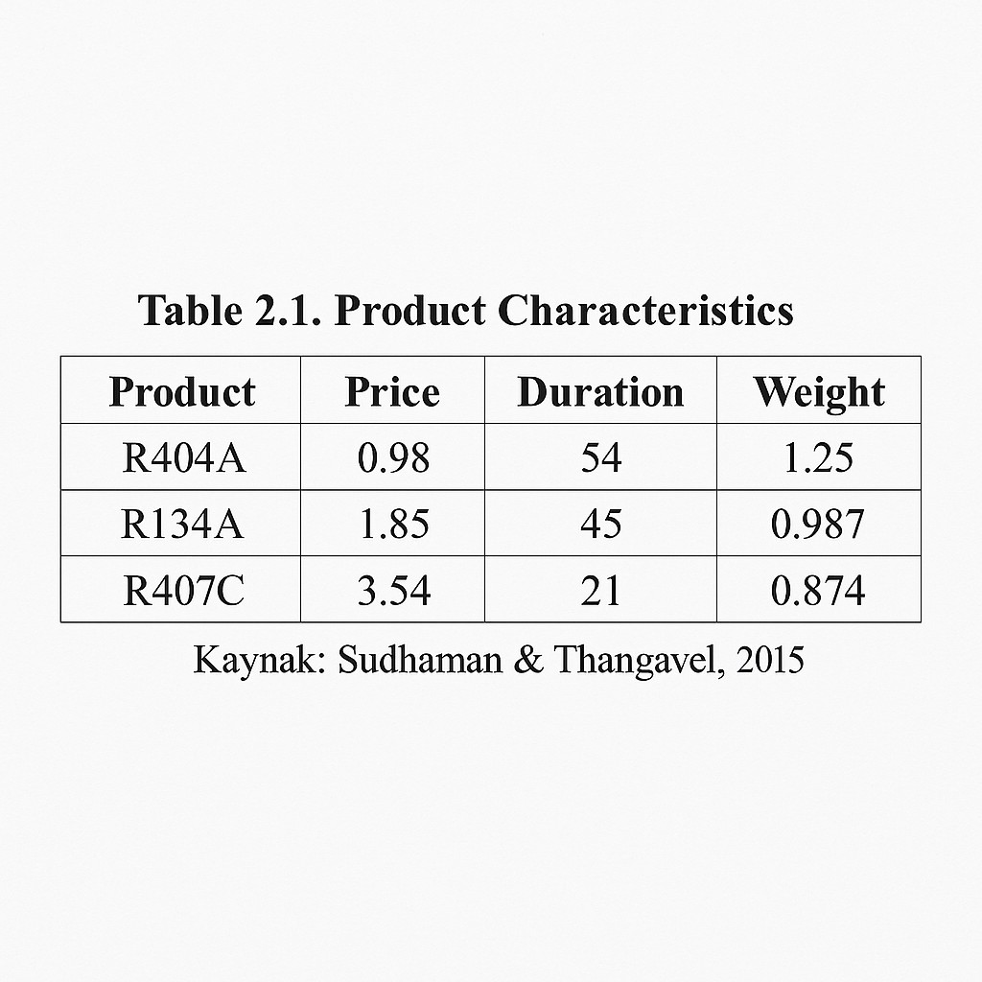
Source:

Relationship Between Tables and the Text:
Every table included in the text must be discussed in the narrative. Clearly explain what the reader should look for in the table but only summarize key features. Although tables support the main text, each table should be interpretable on its own, even without reference to the surrounding content. All abbreviations (except standard statistical ones like M for mean and SD for standard deviation), underlined terms, dashes, and brackets should be explicitly defined. Always indicate the unit of measurement used.
In the text, refer to tables by number (e.g., as shown in Table 2.1), not by placement (e.g., the table above or the following table).

Example:
As shown in Table 1.8, the exhibited responses were higher among children who had received pre-training (see Table 1.5).
Do not use vague expressions such as “the table above”, “the table below”, or “the table on page 32”.

Table Titles:
Each table must have a concise, clear, and descriptive title.

Figures:
In APA style, any visual representation other than a table is considered a figure. This includes diagrams, graphs, photographs, drawings, and other types of illustrations. Figures are especially useful for representing interactions, non-interactions, or nonlinear relationships. A well-designed figure can convey structural or conceptual content more effectively than narrative text.
Multiple types of figures may be used to present information. Sometimes it is easy to decide which type to use; at other times, it requires judgment. Graphs typically display relationships, comparisons, or distributions within data sets—such as absolute values, percentages, or indexes.
Figures should be clean and uncluttered, with irrelevant visual elements removed. Information on the horizontal (x) and vertical (y) axes must be orderly (e.g., ascending values) and consistent (e.g., using comparable units of measurement).
Figures must be numbered sequentially in the order in which they are mentioned in the text. Each figure should be numbered and titled. As with tables, the figure number and title should appear in bold, with each major word capitalized. The figure number, title, and source (if applicable) must be placed below the figure, using single line spacing.
Example:
Figure 2.1. illustrates these rules in practice.
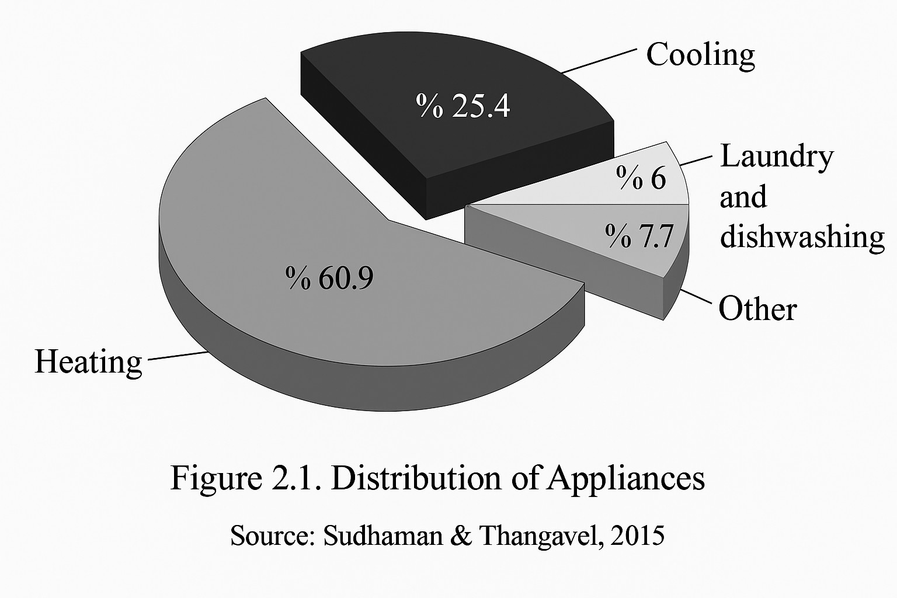

Tables and Figures Taken from Another Source: For all tables (or figures) taken from another source, add a note below the table (or below the figure legend) and indicate the author and the owner of the publication rights. Use the following format for tables and figures.
For material taken from a journal article: Sources. Taken from the study titled " Ortaöğretimdeki Öğretmen ve Öğrencilerin İstenmeyen Davranışlarla Baş Etme Konusundaki Görüşlerinin Karşılaştırılması" published by M. Atıcı and F. Çekici, 2009, Educational Administration in Theory and Practice, 108(60), p.509.
Footnotes and Notes: Notes may be explanatory, extremely important, or referential, depending on where they are used and the information to be conveyed.
Footnotes in the Text: There are two types of footnotes in the text: Footnotes that provide information about the content and footnotes that indicate that permission has been obtained from the publisher when quoted. Content footnotes are used to add to or expand on important information given in the text; these footnotes should not be complex, irrelevant or trivial. A content footnote should focus on conveying a single idea.
Footnotes giving permission to publish are used to acknowledge the source of quotations. Use the recommended word order for tables and figures to be reused.
Number the content and publication permission footnotes used throughout the article in the order in which they are used and use the natural numbers 1,2,3 as superscripts. If you will refer to the same footnote again later, indicate them in parentheses.
Naming and Mentioning Additional Sections in the Text: If your article has only one appendix, call it an Appendix; if your article has more than one appendix, capitalize each one in the order they are mentioned in the main text (e.g., Appendix A, Appendix B). Each appendix should have a title tag. Refer to sections in the text by their label names: see Appendices A and B for all evidence.
Text Body and Headings of Appendix Sections: As with the main text, an appendix may have headings and subheadings, and may include tables, figures and equations. Number each table and figure in the appendix and, if necessary, also number equations so that you can refer to them later; prefix the number with the letter name of the appendix in which the table, figure or equation appears (e.g., Table Al). If there is only one appendix, then the appendix is not given a lettered title. However, to distinguish the tables, figures and equations in the appendix from those in the main text, you should still prefix them with the letter A. All the rules about how to refer to tables and figures in the main text also apply to tables and figures in the appendix: All

tables and figures in an appendix must be mentioned in the same appendix, and they are numbered in the order in which they are mentioned in the appendix.
Tables as Appendices: If a single table forms the whole of an appendix, write the name and title of the appendix centered on the line and use it in place of the table number and title. In general, treat multiple tables as separate appendices. If multiple tables are grouped together in a single appendix (but there is no text), then number these tables.
Tests and Questionnaires: If you wish to reprint another author's test or questionnaire, determine whether permission is required from the rightsholder; obtain permission for print and electronic reuse, if necessary, and include full rightsholder information in your manuscript.
Rules for Writing Numbers in Text: The general rule in APA style regarding the use of numbers is to express numbers 10 and above with numbers and numbers below with words.

H. BIBLIOGRAPHY

Bibliography Indentation Setting: Hanging Bibliography Indent Value: 1.25cm Before: 6 pt
After: 6 pt
Line Spacing: 1.5 lines
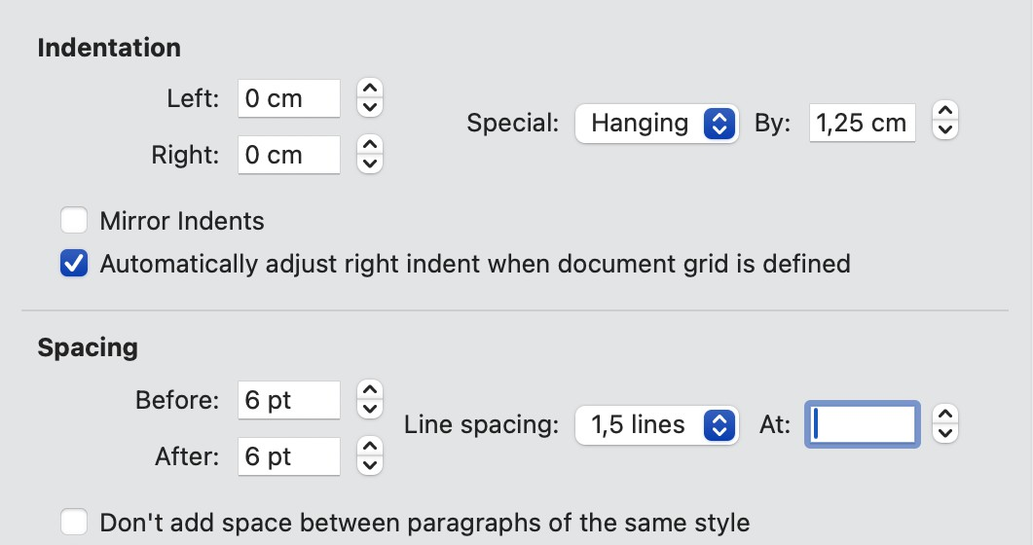

References in the bibliography will be in alphabetical order: Please cite your references in alphabetical order according to the initials of the first author's last name. For special cases, follow the rules below.
- Follow the letters in alphabetical order. Note, however, that names may be placed before

each other by subtle differences. For example, in alphabetical order Brown, J. R., precedes Browning, A. R.
- Alphabetize prefixes such as M, Mc or Mac as they are written, not as they are pronounced. Mac Arthur goes before McAllister and MacNeil goes before M'Carthy.
- Alphabetize surnames that contain phrases (de, la, du, von, etc.) according to the rules of the language in which the name is written. If you know that the prefix is a common part of the surname (e.g. De Vries), treat the prefix as part of the surname (e.g. DeBase precedes De Vries) and alphabetize by prefixes. However, if the prefix is not used in the usual way (e.g. only Hemholtz instead of von Hemholtz), omit it when alphabetizing and write it after the initials (e.g. Hemholtz, H. L. F. von).
- Alphabetize articles with numbers according to the spelling of the numbers.
- Arrangement of multiple sources from a single author in the bibliography: If there is more than one source from a single author, list them in order from previous editions to later editions.
Hewlett, L. S. (1996).
Hewlett, L. S. (1999).

A single-author bibliography item precedes a multi-author bibliography item with the same author:
Alleyne, R. L (2001).
Alleyne, R. L. & Evans, A. J. (1999).

If the first author remains the same and the second or third authors change, alphabetize by the surname of the second author; if the second authors are the same, look at the third, and so on.
Gosling, J. R., Jerald, K., & Belfar, S. F. (2000). Gosling, J. R. & Tevlin, D. F. (1996).
Hayward, D., Firsching, A., & Brown, J. (1999). Hayward, D., Firsching, A., & Smigel, J. (1999).

If studies with the same authors are to be cited, the year of publication will be used again for sorting.

Cabading, J. R. & Wright, K. (2000). Cabading, J. R. & Wright, K. (2001).

When citing works by the same author or authors in the same year, the names of the studies are listed in alphabetical order. However, the words "A" or "The" are not considered in English references.
Exception: If the references with the same author are published in the same year and are called, for example, Part 1 or Part 2, use this order.
Lower case letters - a, b, c and so on - should be written in parentheses, next to the year:
Baheti, J. R. (2001a). Control
Baheti, J. R. (2001b). Roles of

The order of citing the works of different researchers with the same surname:
Authors with the same surname will be listed according to the initials of their first names.
Mathur, A. L. & WalIston, J. (1999). Mathur, S. E. & Ahlers, R. J. (1998).
Note: Add the first author's surname and initials to the citations in the text.
How to cite the work of a group of authors or works with no named author: List the work of a group of authors from organizations or government departments in alphabetical order according to the initials of the organization. The full name of the organization should be given (e.g., American Psychological Association instead of APA).
If and only if the work is designated as "anonymous", the word "Anonymous" is given as a name for the work and the alphabetical ordering is done as if the word "anonymous" were a real name.
If author information is not available, the name of the study is written instead of the author and the order is alphabetized according to the initials of the study.
Give legal sources in the bibliography as sources without author information. That is, alphabetize by the first word of the name (word or abbreviation) of the legal source.

- Citing References in Periodicals

Article authors: Herman, L. M., Kuczaj, S. A., & Holder, M. D.

Year of edition: 1993
Article title: Responses to anomalous gestural sequences by a language-trained dolphin: Evidence for processing of semantic relations and syntactic information.
Name of the journal in which the periodical is published: Journal of Experimental Psychology: General
Volume: 122

Issue: 4
Page Range of the Article: 184-194
Herman, L. M., Kuczaj, S. A., & Holder, M. D. (1993). Responses to anomalous gestural 26 segues by a languagetrained dolphin: Evidence for processing of semantic relations and syntactic information. Journal of Experimental Psychology: General, 122(4), 184-194. doi: 10.1111/cdev.12868

Only the first word of the title and subheadings and proper nouns, if any, should be capitalized.
- When showing the number of pages, it will be shown as 182-194, not p.182-194.
- The second lines of the references in the bibliography will start 3 characters inside.
- The doi of the articles (if any) will be given as a link after the page number.

Sample References to Periodicals

Single Author Journal Article

Ekşi, H. (2006). Bilişsel ahlak gelişimi kuramı: Kohlberg ve sonrası. Abant İzzet Baysal Üniversitesi Eğitim Fakültesi Dergisi, 6(1), 29-38.
Mellers, B. A. (2000). Choice and the relative pleasure of consequences. Psychological Bulletin, 126(2), 910-924.

Journal Article with Two Authors

Karadağ, E. & Öney, A. (2006). İlköğretim birinci kademesinde portfolyo dosyalarının değerlendirme aracı olarak kullanılabilirliği. Ahi Evran Üniversitesi Kırşehir Eğitim Fakültesi Dergisi, 7(2), 235-246.

Klimoski, R., & Palmer, S. (1993). The ADA and the hiring process in organizations Consulting Psychology Journal: Practice and Research, 45(2), 10-36.

Journal Articles with Three-Six Authors

Dilmaç, B., Kulaksızoğlu, A. & Ekşi, H. (2007). Bir grup fen lisesi öğrencisine verilen insani değerler eğitiminin insani değerler ölçeği ile sınanması. Kuram ve Uygulamada Eğitim Bilimleri, 7(2), 1221-1261.
Saywitz, K. J., Mannarino, A. P., Berliner, L, & Cohen, J. A. (2000). Treatment for sexually abused children and adolescents. American Psychologist, 55(4), 1040-1049.

Journal Articles with More Than Six Authors
    - In works with more than six authors, use "et al." after the initials of the sixth author to indicate that other authors are included.
    - In theses written in English, et al. is used, which means and others.

Aker, T., Sorgun, E., Mestçioğlu, Ö., Karakaya, I., Kalender, D., Acar, G. vd. (2008). İstanbul'daki bombalama eylemlerinin erişkin ve ergenlerdeki travmatik stres etkileri. Türk Psikoloji Dergisi, 23(61), 63-74.
Wolchik, S. A., West, S. G., Sandler, I. N., Tein, J., Coatsworth, D., Lengua, L, et al. (2000). An experimental evaluation of theory-based mother and mother-child programs for children of divorce. Journal of Consulting and Clinical Psychology, 68(1), 843-856. Journal Articles in Press
Baloğlu, N. & Karadağ, E. (basımda). Öğretmen yetkinliğinin tarihsel gelişimi ve Ohio Öğretmen Yetkinlik Ölçeği: Türk kültürüne uyarlama, dil geçerliği ve faktör yapısının incelenmesi. Kuram ve Uygulamada Eğitim Yönetimi.
Zuckerman, M. & Kiefer, S. C. (in press). Race differences in face-ism: Does facial prominence imply dominance? Journal of Personality and Social Psychology.

Popular Journal Article
    - Write the date given in the edition, indicating the month for monthly journals and the month and day for weekly journals.

    - Also include the number of the volume.

Özbaşaran Dede, N. (2008, Kasım). Küresel iklim savaşçıları: Solucanlar. Bilim ve Teknik, 492, 11-13.
Kandel, E. R. & Squire, L. R. (2000, November 10). Neuroscience: Breaking down scientific barriers to the study of brain and mind. Science, 290, 1113-1120.

Newsletter Article
    - Use the date given in the issue.
    - Include the number of volumes.

Demir, F. (2006, Haziran). Çevre mevzuatında kirlilik var. Yeditepe Haber, 23, 24-30.
Brown, L. S. (1993, Spring). Antidomination training as a central component of diversity in clinical psychology education. The Clinical Psychologist, 46, 83-87.

Unauthored News Article
Contemporary structuring in knowledge. (2008, March). Uludağ Post, 71, 1-
3. The new health-care lexicon. (1993, August/September). Copy Editor, 4,1- 2.

If it is to be cited in the text, the following path can be followed. According to the news article titled "Modern structuring in information" (2008) ....
As stated in the 2008 news article titled "Modern structuring in information"...

Daily Newspaper Article with Unidentified Author

New drug appears to sharply cut risk of cfeath from hearîh failure. (1993, July 15). The Washington Post, p. A12.
Öğrencilerin dijitalleşme düzeylerinin ölçülmesi. (2008, 16 Kasım). Milliyet, s. 19. If the source is to be cited in the text, the following procedure can be followed.

According to the news report titled "New drug appears..." (1993). As reported in a 1993 news article titled "New drug appears..."

Newspaper Articles Published on Different Pages
    - If an article is published on several discontinuous pages, indicate by placing a comma between the numbers of all pages (e.g., pp. B1,B3,B5-B7).

Schwartz, J. (1993, September 30). Obesity affects economic, social status. The Washington Post, pp. A1, A4.
Saygın, A. (2005, November 11). Pozitif psikoloji. Sabah, p.1,11.

Weekly Newspaper Article, Letter to the Editor
    - Please indicate the letter to the editor, which is expressed as "Letter to the editor" in English, in square brackets after the title of the study.
Berkowitz, A. D. (2000, November 24). How to tackle the problem of student drinking [Letter to the editor]. The Chronicle of Higher Education, p. B20.

An Entire Journal Issue or a Special Section of a Journal
Hesapçıoğlu, M., (Ed.). (2002). Küreselleşme ve eğitim [Özel sayı]. Kuram ve Uygulamada Eğitim Bilimleri, 2(1).
Barlow, D. W. (Ed.). (1991). Diagnoses, dimensions, and DSMIV: The science of classification [Special issue]. Journal of Abnormal Psychology, 100(3).
    - When citing the whole issue or a special section of the journal as a source, write the editors of the issue and the title of the issue. If there is no editor of the issue, use the name of the issue of the journal you are using in place of the author before the year of publication and put a period after it.
    - In order for the reader to easily find the cited work, indicate the numbers of the special issues and the pages where the special sections were published.

Monograph with Serial Number and Journal Number
    - Indicate the volume number of the journal, followed by the series or the entire architecture in brackets. If the monograph is given the whole number, give the whole number, not the serial number.

Harris, P. L, & Kavanaugh, R. D. (1993). Young children's understanding of pretense.
Monographs of the Society for Research in Child Development, 58(1, Serial No. 231).

Monographs Published as a Supplement to a Journal

    - Indicate the number of the journal and the supplementary material or chapter/section number in brackets immediately after the volume number.
Battig, W. F. & Montague, W. E. (1969). Category norms for verbal items in 56 categories: A replication and extension of the Connecticut category norms. Journal of Experimental Psychology Monographs, 80(3, B. 2).

Monograph Given in the Appendix of the Journal and Continuing Page Number
    - In square brackets to indicate the type of article, write Monograph if the source is in English and Monograph if the source is in Turkish.
Ganster, D. C, Schaubroeck, J., Sime, W. E., & Mayes, B. T. (1991). The nomological validity of the type A personality among employed adults [Monograph]. Journal of Applied Psychology, 76, 143-168.

Abstract as Original Source
    - Write Abstract in square brackets between the title and the period following it.
Korkut, Y., Müderrisoğlu, S. & Tanık, M. (2006). Examples of ethical violations encountered in the field of clinical psychology and how they are handled [Abstract]. Turkish Psychological Writings, 9(18), 49.
Woolf, N. J., Young, S. L, Fanselow, M. S., & Butcher, L. L (1991). MAP-2 expression in cholinoceptive pyramidal cells of rodent cortex and hipp-campus is altered by Pavlonian conditioning [Abstract]. Society for Neuroscience, 77, 480.

Abstract from a Secondary Source (Published Periodical)
    - The term "secondary source" includes abstracts, article summaries, book reviews and the like. These are usually derived from primary sources (such as journal articles, papers, books) by someone other than the original author or authors. In academic research, it is preferable to cite the original source.
    - At the end of the source, write "Abstract obtained from" for English and "Abstract

obtained from this source" for Turkish and indicate the secondary source, and then indicate the year of printing, volume number and other features that define the abstract, if available.
    - If the edition year of the secondary source is different from that of the original work, indicate both dates, with the original date first, separated by a taxim sign:
Nakazato, Shimonaka and Homma (1992/1993).
Nakazato, K., Shimonaka, Y., & Homma, A. (1992). Cognitive functions of centenarians: The Tokyo Metropolitan Centenarian Study. Japanese Journal of Developmental Psychology, 3, 9-16. Abstract obtained from PsycSCAN: Neuropsychology, 1993, 2, Abstract No: 604

Journal Supplement
    - Immediately after giving the number of volumes, indicate the number of appendices in brackets.

Regier, A. A., Narrow, W. E., & Rae, D. S. (1990). The epidemiology of anxiety disorders: The epidemiologic catchment area (ECA) experience. Journal of Psychiatric Research, 24 (Suppl. 2), 3-14.

Periodicals Published Annually
    - Consider regularly published publications as periodicals, not books. If sub-titles change in regularly published series, for example, as in the case of published symposium topics (e.g., one title is The Nebraska Symposium on Motivation and another is The Annals of the New York Academy of Sciences), consider these publications as a book or book chapter.
Fiske, S. T. (1993). Social cognition and social perception. Annual Review of Psychology, 44, 155-194

Journal Articles in a Language Other Than English and Translated into English
    - If the original version of a non-English article is used as a source, use the original title of the article in the reference. Indicate the translated title in square brackets immediately after the original title.
    - In the case of non-English languages, do not change the alphabet and alphabetic structure of the original language, but write it as it is (in the example given in this article, double-dotted
letters and capitalized names)

Ising, M. (2000). Intensitâtsabhângigkeit evozierter Potenzial im EEG: Sind impulsive Personen Augmenter öder Reducer? [Intensity dependence in event-related EEG potentials: Are impulsive individuals augmenters or reducers?]. Zeitschrift für Differentielle und Diagnostische Psychologie, 21, 208-217.
    - If an English translation of a non-English article is used, cite the translation as the source and write the English title without brackets.
Brentano, F. (2003). Tasvirci psikoloji ya da tasvirci fenomenoloji. Kutadgubilig Felsefe-Bili Araştırmaları Dergisi, 5, 133-136.
Stutte, H. (1972). Transcultural child psychiatry. Açta Paedopsychiatrica, 38(9), 229-231.

- Citing References in Books, Brochures and Book Chapters Authors of the book: Beck, C. A. J., & Sales, B. D.
Year of Print: 2001
Book Title: Family mediation: Facts, myths, and future prospects.
Edition Information: American Psychological Association.

Beck, C. A. J. & Sales, B. D. (2001). Family mediation: Facts, myths, and future prospects.
American Psychological Association.
Tekeli, Ş. (1995). 1980'ler Türkiye'sinde kadın bakış açısından kadınlar. İletişim Yayınları.
    - Only the first word of the title and subtitles and proper names, if any, are capitalized.
    - The DOI number of the books, if any, will be given as a link after the page number. If a book has more than six authors, use the rules for journals. For the remaining authors, use the abbreviation et al., which stands for and others, followed by a full stop.

Examples Where a Whole Book is Cited

- Book, 3rd Edition; Jr. Abbreviation

Mitchell, T. R., & Larson, J. R., Jr. (1987). People in organizations: An introduction to organizational behavior (3rd ed.). McGraw-Hill.

Book, Group Author as Publisher (Government Department)
  - If the publisher and author are the same person, replace the publisher with Author.
Australian Bureau of Statistics. (1991). Estimated resident population by age and sex in statistical local areas. Author.

Edited Books
Çelebi, N. (Ed.). (1990). Gender role attitudes of our women. Sebat Publications.
Gibbs, J. T., & Huang, L. N. (Eds.). (1991). Children of color: Psychological interventions with minority youth. Jossey-Bass.

Translated Books

Jenson, E. (2006). Beyin uyumlu öğrenme (A. Doğanay, Trans.). Nobel Publication. (Original edition, 1999).

Book Author or Non-Editor
  - Move the title to the place where the author should be indicated.
  - Alphabetize books without author and editor by the first significant word in the title (for the example below, Merriam).
  - When citing in the text, if the title is short, use it as it is, if not, abbreviate it and use it instead of the author's name: (Merriam-Webster's Collegiate Dictionary, 1993).
Merriam-Webster's collegiate dictionary (10th ed.). (1993). Merriam-Webster. Dilbilim açısından Türkçenin görünümü (2nd ed.). (1995). Dil Derneği.

Book: Revised Edition
Rosenthal, R. (1987). Meta-analytic procedures for social research (Rev. ed.). Sage.

Multivolume and Reprinted and Revised More than One Volume, More Than One Year After Publication
Koch, S. (Ed.). (1959-1963). Psychology: A study of science (Vols. 1-6). McGraw-Hill.
  - The notation in the text should be as follows: (Koch, 1959-1963).

Diagnostic and Statistical Manuals of Mental Disorders
  - The institution is both author and publisher.
  - Indicate the edition you are using in numerical brackets.
  - You can write the full name of the institution or guideline in your first citation in the text, followed by its abbreviation in square brackets, and the abbreviation in subsequent citations as shown below:
DSM-IV (1994)
DSM-IV-TR (2000)

Bibliography:
American Psychiatric Association. (1994). Diagnostic and statistical manual of mental disorders (4th Ed.). Author

Encyclopedia or Dictionary
Sadie, S. (Ed.). (1980). The new Grove dictionary of music and musicians (6th ed., Vols. 1- 20). MacMillan.
  - For large works with a large editorial staff, use the abbreviation et al. after the name of the chief editor.

Non-English Books
  - If you are citing a work that is not originally in English, give the original source in the bibliography: first the original title, followed by the English or Turkish translation in square brackets.
Piaget, J. & Inhelder, B. (1951). La genâse de l'ideâ de hasard chez Tenfant [The origin of the idea of chance in the child]. Pressess Universitaries de France.

English Translation of a Book
  - If a translation of a book from a foreign language into Turkish is used as a source, include the translation from the relevant foreign language in the bibliography: Indicate the English title without using square brackets.
  - Indicate the year of the original edition and the year of the translation in the text: (Johnson,

2005/2014), (Laplace, 1814/1951).
Johnson, A. P. (2014). Action research handbook (Y. Uzuner & M. Ö. Anay, Translation). Anı Publishing. (Original work published in 2005)
Laplace, P.-S. (1951). A philosophical essay on probabilities (F. W. Truscott & F. L. Emory, Trans.). Dover. (Original work published 1814)

Brochure, Legal Author
  - When citing pamphlets as references, use the same rules as when citing a whole book.
  - Indicate in square brackets that the publication is a brochure.
Research and Training Center on Independent Living. (1993). Guidelines for reporting and writing about people with disabilities (4th ed.) [Brochure].

An Article or Chapter in an Edited Book Author of the article or chapter: Yıldız, D.
Year of Printing: 1992
Title of the article or chapter: Psychosocial reception analysis of Formula 1 racing.
Editors of the book: Taşkıran, İ. B. & Altunkaya, H. (Ed.).
Title of the book and page numbers of the article or chapter: Motor Sports Academic Journal (pp. 51-84).
Edition Information: Sports Sciences Association.
Yildiz, D. (1992). Psychosocial reception analysis of Formula 1 races. Taşkıran, İ. B. & Altunkaya, H. (Eds.). Motor Sports Academic Journal (pp. 51-84). Sport Sciences Association.

Articles or Chapters in an Edited Book, Two Editors;
Yücel, C. & Gülveren, H. (2006). Students' motivation in the classroom. In M. Şişman & S. Turan (Eds.), Classroom management (pp. 74-88). Pegema.
Bjork, R. A. (1989). Retrieval inhibition as an adaptive mechanism in human memory. In H. L Roediger III & F. I. M. Craik (Eds.). Varieties of memory & consciousness (pp. 309- 330). Erlbaum.

Articles and Chapters in an Edited Book in Print, Volumes with Different Titles in a Multi-Volume Work
  - If the article has not yet been published, do not give the year of publication. Use brackets in the text as follows: (Auerbach, in press)
  - Pages are not identified until the work is published, so you cannot give page numbers for articles and chapters that are in print.
Auerbach, J. S. (in press). The origins of narcissism and narcissistic personality disorder: A theoretical and empirical reformulation. In J. M. Masling & R. F. Bornstein (Eds.). Empirical studies of psychoanalytic perspectives on psychopathology. American Psychological Association.

Chapter in a Volume within a Series
  - You should first indicate the editor of the series and then the editor of the volume.

Maccoby, E. E. & Martin, J. (1983). Socialization in the context of the family: Parent-child interaction. In P.H. Mussen (Series Ed.) & E. M. Hetherington (Vol. Ed.). Handbook of child psychology: Vol. 4. Socialization, personality, and social development (4th ed., pp. 1-101). Wiley.

Non-English Articles in an Edited Book, Title Translated into English
  - If a non-English article or chapter is used as a source, cite the original work in your bibliography: First the original title, then the translated title in square brackets.
Davydov, V. V. (1972). De introductie van het begrip grootheid in de eerste klas van de basisschool: Een experimenteel onderzoek [The introduction of the concept of quantity in the first grade of the primary school: An experimental study]. In C. F. Van Parreren & J. A.
M. Carpay (Eds.), Sovjetpsychologen aan het woord (pp. 227-289). WoltersNoordhoff.

Encyclopedia Article
Öncül, R. (2000). Psychology. Dictionary of education and educational sciences (C.1, S.501-503). Milli Eğitim.
Bergman, P. G. (1993). Relativity. In The new encyclopaedia Britannica (Vol. 26, pp. 501- 508).
Encyclopaedia Britannica.
  - If the article does not have its own author, place the title where the author should be.

English Translation of an Article or Chapter in an Edited Book, Volume of a Multi-Volume Work, Reprinted Works
  - If the source is an English translation of a non-English work, cite the English translation as the source: Do not use square brackets for the English title.
  - To indicate the translator, use the abbreviations Trans. and write the name of the translator immediately after the name of the editor. If the editor is also the translator, indicate this in parentheses immediately after the name.
  - In brackets in the text, cite the following references: (Freud, 1923/1961).
Freud, S. (1961). The ego and the id. In J. Stanchey (Ed. & Trans.), The Standard edition of the complete psychological works of Sigmund Freud (Vol. 19, pp. 3-66). Hogarth Press. (Original work published 1923)

English Translation of Articles and Chapters in an Edited Book, Rewritten from Another Source
  - If an English translation of a non-English work is used as a source, cite the translation as the source: indicate the English title without square brackets.
  - Use brackets in the text as follows: (Piaget, 1970/1988).
Piaget, J. (1988). Extracts from Piaget's theory (G. Gellerier & J. Langer, Trans.). In K. Richardson & S. Sheldon (Eds.), Cognitive deveiopment to adolescence: A reader (pp. 3- 18). Erlbaum. (Reprinted from Manual of child psychology, pp. 703-732, by P. H. Mussen, Ed., 1970, Wiley)

- Citing References in Technical and Research Reports
Report authors: Mazzeo, J., Druesne, B., Raffeld, P. C, Checketts, K. T., & Muhlstein, A.

Year of publication: 1991.
Title of the report: Comparability of computer and paper and pencil scores for two CLEP general examinations (College Board Rep. No. 91-5).
Edition information: Educational Testing Service.

Mazzeo, J., Druesne, B., Raffeld, P. C, Checketts, K. T., & Muhlstein, A. (1991). Comparability of computer and paper and pencil scores tor two CLEP general examinations (College Board Rep. No. 91-5). Educational Testing Service.
Examples of Bibliography Articles Citing Reports

Reports from the Government Printing Office (GPO), State Institute as Group Author
  - For documents received from GPO, Government Printing Office, please indicate GPO as the publisher.
National Institute of Mental Health. (1990). Clinical inaining in serious mental illness (DHHS Publication no. ADM 90-1679). U.S. Government Printing Office.

German Reports from the National Technical Information Service (NTIS, National Technical Information Service)
  - Give the NTIS number in brackets at the end of the item.
Osgood, D. W. & Wilson, J. K. (1990). Covariation of adolescent health problems.
University of Nebraska (NTIS No. PB 91-154 377/AS)

Reports Received from Educational Resources Information Center (ERIC)
  - Give the ERIC number in brackets at the end of the article.
Mead, J. V. (1992). Looking at old photographs: Investigating the teacher tales that novice teachers bring with them (Report No. NCTRL-RR-92-4) East Lansing, MI: National Center for research on Teacher Learning. (ERIC Document Reproduction Service No. ED346082)

University Reports

  - If the name of the university includes the name of the state, city or country, do not repeat this information when giving the edition information.
  - State the name of the university first, followed by the name of the department or organization that produced the report.
Önortaç, N. (2007). The acquis communautaire of the European Union (Tek. Rap. No. 11).
Yeditepe University Management Application and Research Center.

Broadhurst, R. G. & Maller, R. A. (1991). Sex offending and recidivism (Tech. Rep. No. 3).
University of Western Australia, Crime Research Center.

University Reports, Edited Report, Monograph
Shuker, R., Openshaw, R., & Soler, J. (Eds.). (1990). Youth, media, and moral panic in New Zealand: From hooligans to video nasties (Delta Research Monograph No. 11). Massey University, Department of Education.

Reports of a Private Organization
  - Use this citation form for special issue reports, business papers and other company-related documents. Give the document number in brackets to access the file.
Eğitim Sen (2006, September). Türkiye'nin eğitimin durumu göstergeleri. Author. Employee Benefit Research Institute (1992, February). Sources of health insurance and characteristics of the uninsured (Issue Brief No. 123). Author.

- Citing References in Meeting and Symposium Proceedings

Published Proceedings, Publications Contributing to the Symposium, Article or Chapter in an Edited Book
  - The name of the symposium is a proper name and should be capitalized.
  - If the name of the university includes the name of the state, city or country, do not repeat this information in the printing information section.
Eyim, A. (2006). Universiter yapıda bilimsel özgürlük ve yönetsel özerkliğin yeri ve önemine sosyolojik bir bakış. R. Yıldız (Ed.). In Social Sciences Education Congress (pp.52-64). Yüzüncü Yıl University
Deci, E. L, & Ryan, R. M. (1991). A motivational approach to self: Integration in personality. In R. Dientsbier (Ed.). Nebraska Symposium on Motivation: Vol. 38. Perspectives on motivation (pp. 237-288). University of Nebraska Press.

Regularly Published Proceedings
  - Treat regularly published reports as periodicals and follow the rules for citing periodicals.

  - Notes. If the minutes contain only the abstract of an article, write [Abstract] for English and [Öz] for Turkish after the title of the article. You should use square brackets so that the reader understands that this is a definition and not a title.
Cynx, J., Williams, H., & Nottebohm, F. (1992). Hemispheric differences in avian song discrimination. Proceedings of the National Academy of Sciences, 89, 1372-1375.

Publications Contributed to the Symposium but Not Published
  - Please indicate the year and month of the symposium.
Çakmak, Z., & Güre Duru, A. (2016, September). The investigation of the relationship among mother's reports of economic hardship, marital conflict and adolescent's problem behaviors in the framework of the family stress model: A follow up study [Oral presentation]. XVth Biennial Conference of the European Association for Research on Adolescence, La Barrosa, Spain.

Studies Presented at a Meeting but Not Published
Karadağ, E. & Öney, A. (2006, September). Okul yöneticilerinin stres düzeylerinin öğretmenlerininstres düzeylerine etkisinin incelenmesi. Paper presented at 14th National Psychology Congress. Hacettepe University, Department of Psychology.
Lanktree, C, & Briere, J. (1991, January). Early data on the Trauma Symptom Checklist for Children (TSC-C). Paper presented at the meeting of the American Professional Society on the Abuse of Children.

Poster Presentation (Visual Presentation)
  - Specify the month in which the meeting took place.
Kındap, Y., Sayıl, M. & Kumru, A. (2006, December). Ergenlerin olumlu ve olumsuz arkadaşlıklarında anneden algılanan kontrol, akran ilişkilerinin niteliği ve benlik değerinin rolü. Poster presented at 11th Adolescent Days Congress, Hacettepe University.
Ruby, J. & Fulton, C. (1993, June). Beyond redlining: Editing software that works. Poster session presented at the annual meeting of the Society for Scholarly Publishing,

- Citing References in Doctoral and Master's Theses

Master's and Doctoral Theses Obtained from Universities in Turkey and Published in YÖK
Gökbulut, R. İ. (2009). Hissedar değeri ile finansal performans ölçütleri ilişkisi ve İMKB üzerine bir araştırma [Doctoral dissertation, Istanbul University]

Doctoral Dissertations Received from UMl and Abstracted in Dissertation Abstract International
  - If the thesis is taken from UMI, give the UMI number along with the DAI page numbers and volume number.
Bower, D. L. (1993). Employee assistant programs supervisory refferals: Characteristics of referring and nonreferring supervisors [Dissertation Abstracts International, 54 (01), 543B]. (UMI No. 9315947)

Doctoral Dissertations with Extracts from the DAI and Obtained from the University
  - If a copy of a doctoral thesis from a university is used as a source, give the name of the university, the year of publication, volume number and DAI page numbers.
  - If a master's thesis from the university included in the International Master's Thesis Abstracts is used as a source, follow the format shown here. Include the year of publication, title of the work, volume and page numbers along with the name of the university where the thesis was published.
Ross, D. F. (1990). Unconscious transference and mistaken identity: When a witness misidentifies a familiar and innocent person from a lineup [Doctoral dissertation, Corneli University]. Dissertation Abstracts International, 51, 417.

Unpublished Doctoral Dissertations

Wiffley, D. E. (1998). Interpersonalanalyses of buiimia Normalweightand obese [Unpublished doctoral dissertation, University of Missouri].

Unpublished Master's Theses from Universities Outside the USA
Akalın, Ö. (2006). Okul Öncesi öğretmen adaylarının meslek algıları ile geleceğe yönelik umut düzeylerinin karşılaştırılması [Unpublished master's thesis, Marmara University].

Almeida, D. M. (1990). Father's participation in family work: Consequences for fathers' stress and father-child relations[Unpublished master's thesis, University of Victoria].

- Citing References in Unpublished Studies or Studies in Limited Circulation

Unpublished, Not Yet Submitted for Publication Manuscript Drafts
Karadağ, E. (2003). Ruhsal liderlik ve örgüt kültürü: Bir yapısal eşitlik modelleme çalışması [Unpublished manuscript draft].
Stinson, C, Milbrath C, Reidbord, & Bucci, W. (1992). Thematic segmentation of psychotherapy transcripts for convergent analyses [Unpublished manuscript].

Unpublished Manuscript Received from University
Yeşil, R., Karadağ, E. & Çalışkan, N. (2002). Akademik dergi editörlerinin makale yayın sürecinde sergilemiş oldukları tutumlara ilişkin bir çalışma [Unpublished manuscript draft, Ahi Evran University].
Depret, E. F., & Fiske, S. T. (1993). Perceiving the powerful: Intriguing individuals versus threatening groups [Unpublished manuscript, University of Massachusetts].

Manuscripts Submitted for Review but Not Yet Approved, Work in Progress
  - Do not indicate the name of the publisher or journal to which the manuscript was submitted.
  - Cite a manuscript or work in progress in the bibliography in the same way, but replace the phrase at the end of the article with Manuscript in preparation in English (do not use "in preperation" in English or "in preparation" in Turkish). When referring in the text, use the date of the copy you have.
  - Include the name of the university if available.
Karadağ, E. (2008). Yapısal eşitlik modeli ve path analizinin temel özellikleri ve eğitim araştırma metodolojisindeki yeri ve önemi. Draft manuscript submitted for review.
McIntosh, D. N. (1993). Religion as schema, with implications for the relatıon between religion and coping. Manuscript submitted for publication.

Unpublished Raw Data of Studies, Untitled Studies
Bordi, F., & LeDoux, J. E. (1993). [Auditory response latencies in rat auditory cortex].
Unpublished raw data.

  - Do not italicize the title of the study; indicate it in square brackets to make it clear that it is not the title.

Studies in Limited Publication
  - In brackets immediately after the title of a limited publication, give a name or address where the publication can be obtained.
  - If the publication is available on the Internet, give only the Internet address or e-mail address for contact instead of a real address.
Klombers, N. (Ed.). (1993, Spring). ADAA Reporter (Avai I ab I e from the Anxiety Disorders Association of America, 6000 Executive Boulevard, Suite 513, Rockville, MD 20852).
- Citing References in Review Articles

Author of the review article: Mroczek, D. K.
Year of Print: 2000
Review article title: The emerging study of midlife.
Type of press reviewed: Review of the book.
Study under review: Life in the middle: Psychological and social development in middle age.
Title and edition information of the periodical: Contemporary Psychology: APA Review of Books, 45, 482-485.
Mroczek, D. K. (2000). The emerging study of midlife [Review of the book Life in th middle: Psychological and social development in middle age]. Contemporary Psychology: APA Review of Books, 45, 482-485.

Examples of references for reviews:
- Book Reviews
  - If the review does not have a title, use the subject as a title in square brackets. Use square brackets so that the reader can understand that what is given is not a title, but descriptive features of the publication.
  - Also indicate in square brackets the type of the work under review (book, film, television program, etc.).

Eğri, T. (2008). Marksist ahlak ve toplum teorisi [Evaluation of the book Marxism, Morality and Social Justice], Journal of Business Ethics, 1, 163-167.
Schatz, B. R. (2000). Learning by text or context? [Review of the book. The social life of information]. Science, 290, 1304.

Movie Reviews

Durak, E. Ş. (2007). Film analizi yönetimi ile Virginia satir aile terapisi yaklaşımına bir bakış [Evaluation of the movie Annem Uğruna]. Turkish Psychological Writings, 10(20), 43-62.
Kraus, S. J. (1992). Visions of psychology: A videotext of classic studies [Review of the motion Picture Discovering Psychology]. Contemporary Psychology, 37, 1146-1147.

- Source Citation of Audiovisual Media

Motion Picture
  - Name the primary person(s) who is the producer or director, followed by their role in brackets, (producer, director or both)
  - Immediately after the title, indicate in square brackets that the work is a movie.
  - Include the country where the movie was produced (where the movie was first released) and the name of the studio. Note that, depending on the movie, the studio may be represented by other countries. In the example above, You Can Count On Me was produced and released in the USA. However, the Miramax studio's Il Postino (The Postman) was originally produced and released in Italy, so the country for this film should be Italy.
  - If the film was released in limited release, give the name of the distributor and their address in brackets at the end of the article.
Deveci, S. (Producer) & Oğuz, A. (Director). (2006). Mutluluk [Motion picture]. ANS & Highway Film.
Scorsese, M. (Producer) & Lonergan, K. (Writer/Director). (2000). You can count on me (Motion picture]. Paramount Pictures
Harrison, J. (Producer) & Schmiechen, R. (Director). (1992). Changing our minds: The story of Evelyn Hooker [Motion picture]. (Available from Changing Our Minds, Inc.)

American Psychological Association (Producer). (2000). Responding therapeuticaiiy to patienî expressions of sexual atîraciion: A stimulus training tape [Motion picture], (Available from the American Psychological Association)

Television Broadcasting
Crystal, L. (Executive Producer). (1993, October 11). The MacNeil/Lehrer news hour [Television broadcast]. Public Broadcasting Service.
Güçlü, A. (Production manager), (2004, February 21). Genç bakış [Television broadcast].
Kanal D Company.

Television Series
Türkoğlu, A. (Producer) & Gürtop, H. (Director). (2005). Hayat törpüsü [Television series].
Koliba Film.
Miller, R. (Producer). (1989). The mind [Television series]. WNET

A Single Episode of a Television Series
  - In place of the author, first indicate the scriptwriters and then the director (indicate the person's position in brackets immediately after his/her name).
  - Put the producer of the series in the editor position.
Bozkurt, S. & Karaoğlu, L. (Screenplay), Türkoğlu, A. (Producer). (2005). Yaşama tutkusu [Television series episode]. H. Gürtop (Director) Hayat türküsü içinde. Koliba Film.
Hail, B. (Writer), & Bender, J. (Director). (1991). The rules of the game [Television series episode]. In J. Sander (Producer). fly away. New York Broadcasting Company.

Music Recordings General Format:
Writer, A. (Date of copyright). Title of song [Recorded by artist if different from writer]. On
Title of album [Medium of recording: CD, record, cassette, ete.]. Location: Label, (Recording date if different from copyright date)

Registration:

Yayla, B. & Filiz, S. (2004). Senden kalan. Pervane üstünde [CD]. Kalan Music. Shocked, M. (1992). Over the waterfall. On Arkansas traveler [CD]. PolyGram Music

Recordings remade by an artist other than the author:
Goodenough , J. B. (1982). Tails and trotters [Recorded by G. Bok, A. Mayo, & E. Trickett].
On And so will we yet [CD]. Folk-Legacy Records. (1990)
Müren, Z. (1976). Bir yangının külünü [Recorded by M. Abacı]. Zirvedeki şarkılar üstünde [CD].
Yavuz & Burç Records.
- In the text, indicate the face of the tape and the track number: "Tails and Trotters" (Goodenough, 1982, track 5).

Sound Recordings
  - Identify the name and position of the original owners and contributors (such as Costa, the speaker in the example above).
  - Immediately following the title, indicate in square brackets the recording medium (in this case a tape recording). Give the recording number in brackets if necessary to make the work easy to find. The brackets indicate the type of medium used. You do not need to use square brackets if the recording medium is included in the identification needed to locate the work.
  - Give the name and address of the distributor, (in the example above, the American Psychological Association).
Costa, P. T., Jr. (Speaker). (1988). Personality, contiunity, and changes of adult life (Cassette Recording No. 207-433-88A-B). American Psychological Association.

I. Electronic Media

Periodicals
- Internet Articles Based on a Printed Source
Çırık, İ. (2008). Çok kültürlü eğitim ve yansımaları [Electronic version]. Hacettepe University Journal of Faculty of Education, 34, 27-40.
VandenBos, G., Knapp, S., & Doe, J. (2001). Role of reference elements in the selection of resources by psychology undergraduates [Electronic Version]. Journal of Bibliographic Research, 5, 117-123.
  - If you are using an online article that you believe has changed (e.g., format or page number differences from the printed source), or if you believe it contains additional data or commentary, you should include the date of the day you obtained the article from the URL.

Çırık, İ. (2008). Çok kültürlü eğitim ve yansımaları. Hacettepe University Journal of Faculty of Education, 34,27-40. http://www.efdergi.hacettepe.edu.tr/CIRIK.pdf. Access date:
18. 11. 2013
VandenBos, G., Knapp, S., & Doe, J. (2001). Role of reference elements in the selection of resources by psychology undergraduates. Journal of Bibliographic Research, 5, 117-123. Retrieved October 13, 2001, from http://jbr.org/article.html

Articles Published in Online Journals Only
Yeşilyurt, S. (2008). Üniversiteye giriş sınavına hazırlanan öğrencilerin dershaneleri tercih etme sebepleri ve dershanelerdeki biyoloji öğretiminin durumu üzerine bir çalışma. Turkish Journal of Science Education, 5(2). http://www.tused.org/intemet/tufed/default13.asp. Accessed on 16.
08. 2008.
Fredrickson, B. L. (2000, March 7). Cuitivating positive emotions to optimize health and well- being. Prevention & Treatment 3, Article 0001a. Retrieved November 20, 2000, from http://journals.apa.org/prevention/volume3/pre0030001 a.html.

Articles Obtained via FTP (File Transfer Protocol) and Published in Online Journals Only
Crow, T. J. (2000). Did Homo sapiens speciate on the y chromosome? Psychologist, 11. Retrieved from March 25, 2001, from ftp://ftp.princeton.edu/harnad/Psycholoquy/2000.volume.11/psyc.00.11.001.languagesexch oromosomes. 1 .crow

Newsletter Articles Published Online Only
  - Use the full print date given in the article as it is.
  - Note that there are no page numbers.
  - In an online periodical, volume and issue numbers are usually not needed.
If they are not used, you can simply give the name of the periodical in the bibliography.
  - If you are using an online article that you believe has changed (e.g., format or page number differences from the printed source), or if you believe it contains additional data or commentary, you should include the date of the day you obtained the article from the URL.

Çırık, İ. (2008). Çok kültürlü eğitim ve yansımaları. Hacettepe University Journal of Faculty of Education, 34,27-40. http://www.efdergi.hacettepe.edu.tr/CIRIK.pdf. Access date:
18. 11. 2013
VandenBos, G., Knapp, S., & Doe, J. (2001). Role of reference elements in the selection of resources by psychology undergraduates. Journal of Bibliographic Research, 5, 117-123. Retrieved October 13, 2001, from http://jbr.org/article.html

Articles Published in Online Journals Only
Yeşilyurt, S. (2008). Üniversiteye giriş sınavına hazırlanan öğrencilerin dershaneleri tercih etme sebepleri ve dershanelerdeki biyoloji öğretiminin durumu üzerine bir çalışma. Turkish Journal of Science Education, 5(2). http://www.tused.org/intemet/tufed/default13.asp. Accessed on 16.
08. 2008.
Fredrickson, B. L. (2000, March 7). Cuitivating positive emotions to optimize health and well- being. Prevention & Treatment 3, Article 0001a. Retrieved November 20, 2000, from http://journals.apa.org/prevention/volume3/pre0030001 a.html.

Articles Obtained via FTP (File Transfer Protocol) and Published in Online Journals Only
Crow, T. J. (2000). Did Homo sapiens speciate on the y chromosome? Psychologist, 11. Retrieved from March 25, 2001, from ftp://ftp.princeton.edu/harnad/Psycholoquy/2000.volume.11/psyc.00.11.001.languagesexch oromosomes. 1 .crow

Newsletter Articles Published Online Only
  - Use the full print date given in the article as it is.
  - Note that there are no page numbers.
  - In an online periodical, volume and issue numbers are usually not needed.
If they are not used, you can simply give the name of the periodical in the bibliography.
  - Wherever possible, the URL should take the reader directly to the article.
- If the URL does not fit on one line, or if it goes on a second line after a slash or period, do not use any hyphens (do not allow the scripting program to automatically add hyphens).

Gören, R. (2007, April). Bilgi toplumu süreci. Preschool Education News Bulletin, 2, http://ooegm.meb.gov.tr/duyuru/bulten2.pdf. Access date: 18.11.2010.
Glueckauf, R. L, Whitton, J., Baxter, J., Kain, J., Vogelgesang, S., Hudson, M., et al. (1998 Juty).
Videocounseling for families of rural teens with epi lepsy - Project update.
Telehealth News, 2(2). Retrieved June 6, 2000, from http://www.telehealth.net/ subscribe/newslettr_4a.html#1

Non-Periodical Publications on the Internet

- Multi Page Documents Prepared by a Private Organization, Undated
  - If a web document consists of multiple pages (i.e. different sections have different URL addresses), specify the URL of the main page that the document belongs to.
  - If the date of publication is not given, use the abbreviation n.d. for English and t.y. for Turkish.
Turkish Psychological Counseling and Guidance Association (n.d.). Code of ethics for those working in the field of psychological counseling and guidance. http://www.pdr.org.tr. Accessed: 16.11.2008.
Greater New Milford (CT) Area Healthy Community 2000, Task Force on Teen and Adolescent Issues. (n.d.). Who has time for a familty meal? You do! Retrieved October 5, 2000, from http:// www.familymealtime.org

Section or Chapter in an Internet Document
  - Put the number of the chapter or section (if given) where you would normally give page numbers.
  - If the direct URL of the chapter or section is available, include this address in your bibliography.
Bankacılık Düzenleme ve Denetleme Kurumu. (2013, November). Interactive monthly bulletin. http://www.bddk.gov.tr/WebSitesi/turkce/Istatistiki_Veriler/Istatistiki_Veriler.aspx, Date of access: 01.02.2014
Benton Foundation. (1998, July 7). Barriers to closing the gap. In Losing ground bit by bit: Low income communities in the Information age (chap. 2). Retrieved August 18, 2001, from http://benton.org/Library/Low-lncome/t wo.html

If it will be given as a source in the text, it should be as follows. If the source is a website (Wikipedia, etc.) or social media page (Facebook, etc.); the name of the page or post is written, followed by the name of the site with a colon. None of them are italicized. The URL is added at the end and the date of retrieval is indicated with the phrase "retrieved from".
. post/status/info [name of facebook account]. Facebook. http://xxxxx retrieved on March 20, 2020.
. Attentional Control. Wikipedia. retrived March 22, 2020, from http://xxxxx

Independent Documents, Author and Date Unspecified
  - If the author of the file is not indicated, start your bibliography with the title of the file.
Kişilik bozuklukları (n.d.). www.gata.edu.tr/dahilibilimler/ruhsagligi/dersnot%205.6. Date of access: 15.12.2010

Documents in the University Program or on the University Department Web Page
Can, G. (2008). Gelişim ve öğrenme. Anadolu University Faculty of Education Web site: http://orgunx.anadolu.edu.tr/egitim.asp. Access date, 17.04. 2008

  - If the file is obtained from a long and complex website (such as a university or government agency), identify the organization, required program, or section immediately before the URL address of the document and place a colon immediately before the URL address.

Technical and Research Reports

- Published Reports from the University on the Website of a Private Organization
Gaziantep Üniversitesi (2004, July). Eğitim ihtiyacı analizi raporu. Gap Regional Development Administration Web site. http://www.g a p . g o v . t r / T u r k i s h / G e g i t i m / y y r a p o r l .pdf. Access date: 17.05.2008.
University of California, San Francisco, Institute for Health and Ging. (1996, November). Chronic care in America: A 21 st century challenge. Retrieved September 9, 2000, from the Robert Wood Johnson Foundation Web site: http://www.rwjf.org/library/chrcare/
  - If the author of the article and the publisher of the article at the Web address are

significantly different (e.g., the organization acting as a server), include the publisher when providing information on how to access the document.
  - Note: If the source is no longer available at the address you are using, this means that you need to update your bibliography.

Government Reports on the State Department Website, Publication Date Unspecified
Sosyal Sigortalar Kurumu (n.d.). 2001 year Statistics manual. http://www.sgk.gov.tr/istatistikler.html. Accessed: 18.10.2008.
United States Sentencing Commission. (n.d) 1997 sourcebook of federal sentencing statistics.
Retrieved December 8. 1999, from http://www.ussc. gov/annrpt/1997/s btoc97.htm

Reports Prepared by a Private Organization and Available on the Organization's Website
Eğitim-Sen (2006). Okullarda şiddetin kaynağı. http://www.egitimsen.org.tr/down/siddet.pdf.
Date of access: 18.11.2008.
Canarie, Inc. (1997, September 27). Towards a Canadian Health IWAY: Vision, opportunities and future steps. Retrieved November 8, 2000, from http://www.canarie.ca/press/publications/pdf/health/ healthvision.doc

Technical Report Extract from a University Page
  - If the retrieved source is an abstract of the study rather than the whole study, indicate this by writing [Abstract retrieved] in English and [Abstract retrieved from . . .] in Turkish at the beginning of the access information.
Uslu, A., Şakrak, M, Çinko, L, Akıl, G., Yurtkoru, S. E. & Durmuş, B. (2008). Marmara Üniversitesi stratejik planı -2009-2013- (Marmara University Strategic Planning Center Report No: 2008/01). http://www.marmara.edu.tr/dosya/duyuru/plan_sonsekli18[1].pdf.
Date of access: 18.10. 2008.
Kruschke, J. K., & Bradley, A. L. (1995). Extensions to the delta rule of associative learning (Indiana University Cognitive Science Research Report No. 14). Abstract retrieved October 21, 2000, from http://www.indiana.edu/~kruschke/deltarule_abstract.html

Meeting and Symposium Proceedings

- Studies Presented at a Symposium, Abstract from University Website
Karadağ, E., Baloğlu, N., Korkmaz, T. & Yüksel, S. (2008, September 03). Öğretmen adaylarındaki kontrol odağı yönelimlerinin öğretmenlik mesleğine yönelik tutumlarına etkisi: Bir path analizi çalışması. Paper presented at the 17th National Congress of Educational Sciences. Available at www.sakarya.edu.tr/17uebk/bildiriler.karadag. Access date: 19.09.2008
Cutler, L. D., Fröhlich, B., & Hanrahan, P. (1997, January 16). Two-handed direct manipulation on the responsive workbench. Paper presented at the 1997 Symposium on Interactive 3D Graphics. Abstract retrieved June 12, 2000, from http://www.graphics.standford.edu/papers/twohanded/

Articles Presented at a Virtual Conference
Tan, G., & l_ewandowsky, S. (1996). A comparison of operator trust in humans versus machines. Paper presented at the CybErg 96 virtual conference. Retrieved May 16, 2000, from http://www.curtin.edu.au/conference/cyberg/centre/outline.cgi/frame?dir=tan
  - Please note that location information is not available for online conferences (i.e. conferences that take place entirely online). E-mail. An e-mail sent from one person to another should be considered a personal communication and should be included in the bibliography as such.

Messages to Newsgroups
  - If the author's full name is available, enter the first letters of the last name and then the first letters of the first name. If there is only one image name to be displayed, use it.
  - Specify the exact date the message was posted.
  - Immediately after the date, write the subject of the message without italics. If there is any additional information that would make it easier for the reader to find the message, include it in square brackets immediately after the message subject line.
  - Immediately after the address of the newsgroup, indicate that this material was obtained from that address. For English use "Message posted to", for Turkish use "... received from ...". Do not forget to write the word news in proto colde.
Chalmers, D. (2000, November 17). Seeing with sound [Msg 1]. Message posted to news://sci.psychology.consciousness

Messages Posted to an Online Forum or Discussion Group
Simons, D. J. (2000, July 14).New resources for visual cognition [Msg 31]. Message posted to http://groups.yahoo.com/group/visiualcognition/message/31

Messages Sent to Electronic Correspondence Lists
  - Include the name of the electronic correspondence list and the address of the archive where the message is located.

Hammond, T. (2000, November 20). YAHC: Handle Parameters, DOI Genres, ete. Message posted to Ref-ünks eleetronic mailing list, arehived at http://www.doi.org/mail-archive/ref- link/ msg00088.html

Other Electronic Resources
- Electronic Copy of Journal Articles with 3-5 Authors Retrieved from Database
Borman, W. C, Hanson, M. A., Oppler, S. H., Pulakos, E. D., & White, L. A. (1993). Role of early supervisory experience in supervisor performance. Journal of Applied Psychology, 78, 443-449. Retrieved October 23, 2000, from the PsycARTICLES database.

Daily Newspaper Article, Electronic Copy Found as a Result of Search
Hitts, P. J. (1999, February 16). In forecasting their emotions, most people flunk out. New York Times. Retrieved November 21, 2000, from http:// www.nytimes.com Çakmakçı, N. (2004,
13 September). Quickly Let's not forget. Hürriyet. http://hurarsiv.hurriyet.com.tr/goster/haber.aspx?viewid=467797. Date of access: 18.11.2008.

Extract from a Secondary Database, Electronic Copy
Fournier, M., de Ridder, D., & Bensing, J. (1999). Optimism and adaptation to multiple sclerosis: What does optimism mean? Journal of Behavioral Medicine, 22, 303-326. Abstract retrieved October 23, 2000, from PsycINFO database
Computer programs, software and software languages: There is no need to write references for standard software and programming languages such as Microsoft Word, Excel, Java, Adobe Photoshop and even SAS and SPSS. It is enough to give the name and version of

the software in the text. However, for special software and computer programs with limited distribution, you must provide the source.

Computer Software
Macit, S. (2007). Akademik benlik kavramı ölçeği 1.0 [Computer writing]. Akade.

Miller, M. E. (1993). The Interactive Tester (Version 4.0) [Computer software]. Psytek Services.

Computer Software and User Manual on the University Website
  - Do not italicize software, programs or languages.
  - If the software is copyrighted by an individual, put that individual's name in place of the author; if no such individual exists, cite such works in the format appropriate for works without an author.
  - Identify the source of the computer program, language and software in square brackets immediately following the title. Do not use a period between the title and brackets.
  - Give the location and name of the organization that produced the work (if available) in the publisher position.
  - To cite a manual as a source, give the same information. However, indicate in square brackets after the title whether the source is a computer program or software manual.
Arıkan, A. (2008). Medya araştırmaları için temel içerik çözümlemesi [Computer software and user manual], http://www.yeditepe.edu.tr/egitim/arikan.html. Date of access:15.11. 2008
Schwarzer, R. (1989). Statistics software tor meta-analysis [Computer software and manual]. Retrieved March 23, 2001, from
http://www.yorku.ca/faculty/academic/schwarze/meta_e.htm

Raw data
- Data File Available in Government Office
  - Following the title, in square brackets (just before the period), give a description of the material (in this case, Data file).

National Health Interview Survey - Current health topics: 1991- Longitudinal study of aging (Version 4) [Data file]. Hyattsville, MD: National Center for Health Statistics.

Data Files Available on the NTIS Website

Use the phrase available from to indicate that the URL address does not refer to the material itself, but provides information on how to access the material you cite as a source as ("available from this source").

